How to define Scala UDF in Spark

|  |
| --- |
| <http://wpcertification.blogspot.in/2016/07/blog-post.html?utm_source=twitterfeed&utm_medium=twitter>  case class ser(firstName:String, lastName: String, age:Integer) |
|  | val users = Seq( |
|  | User("Sachin","Tendulkar",43), |
|  | User("Rahul","Dravid",43), |
|  | User("Virat","Kohli",27), |
|  | User("MahendraSingh","Dhoni",34) |
|  | ) |
|  | val userDF = sc.parallelize(users).toDF() |
|  | val evenNumber = udf{age:Integer => age%2 == 0} |
|  | val usersWithEvenNumberAge = userDF.filter(evenNumber(userDF("age"))) |
|  | usersWithEvenNumberAge.show() |

Info: **Tesseract** is an [optical character recognition](https://en.wikipedia.org/wiki/Optical_character_recognition) engine (ocr)–

Extracting character from image(TIFF).

Note:

* **Transformations provide a new RDD**
* **Action provides a Result**

<https://www.youtube.com/watch?v=ZTFGwQaXJm8>

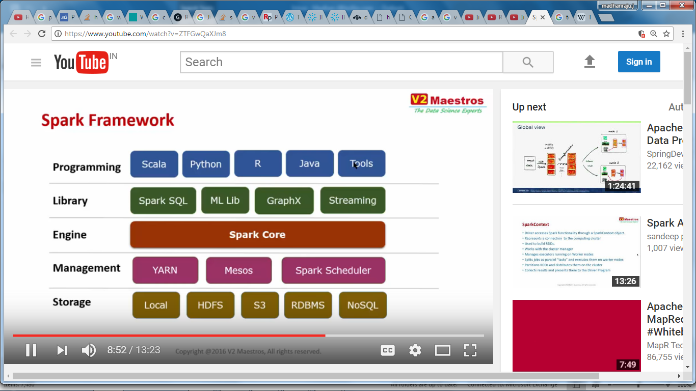

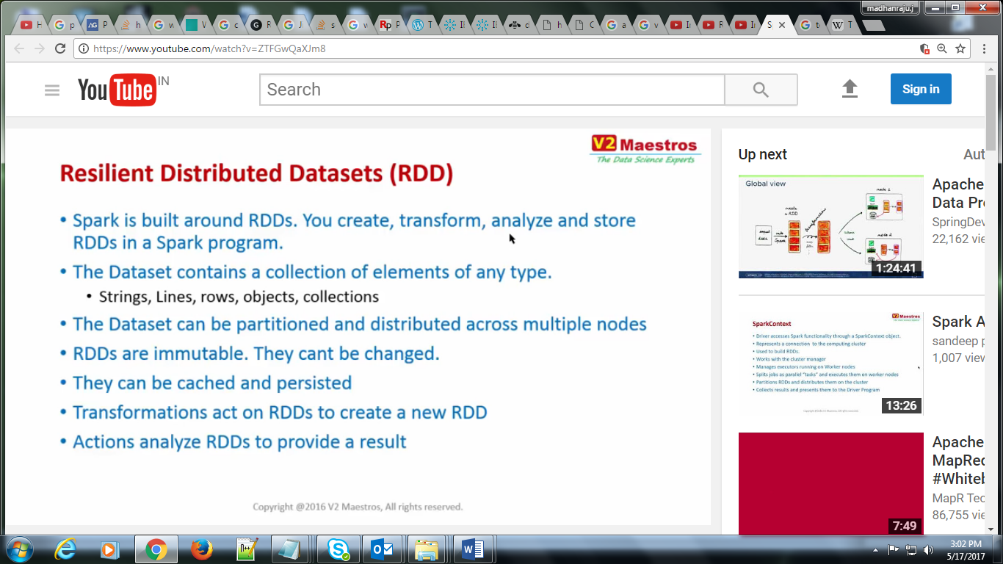

https://www.youtube.com/watch?v=pZQsDloGB4w

DataFrame API

----------------

DataFrame API provides a higher-level abstraction (a DSL, really),

allowing you to use a query language to manipulate data. in fact, you can use SQl, as will

-- with DataFrames we are closer to what we are trying to do; rather than how we are tying to do.

look how much easier it is to read.

val df = parsedRDD.toDF("project", "numRequests")

df.groupBy($"page").

agg(sum($"numRequests").as("count")).

limit(100).

show(100)

But we've lost type safety (to handle this they come up with DataSets)

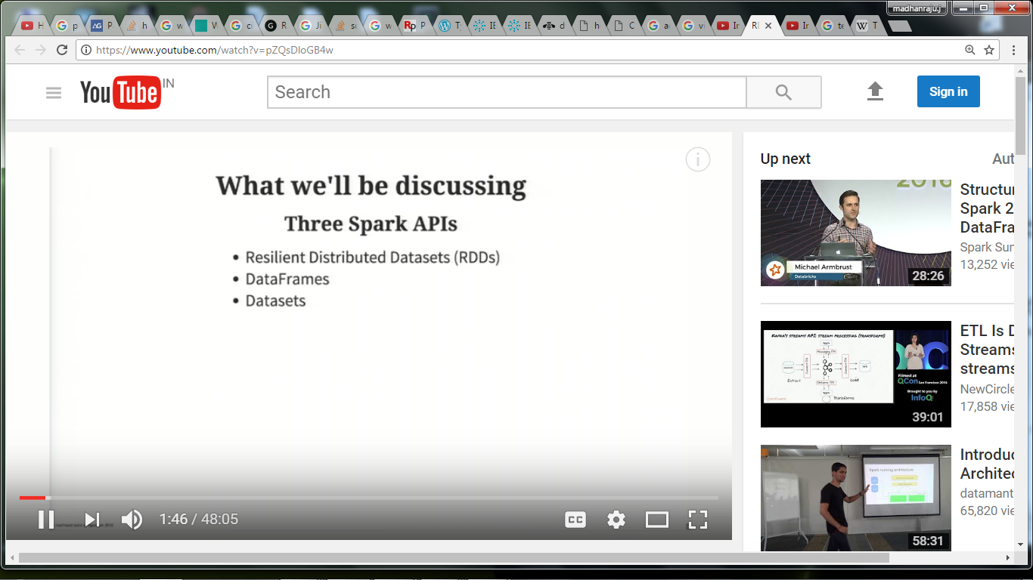

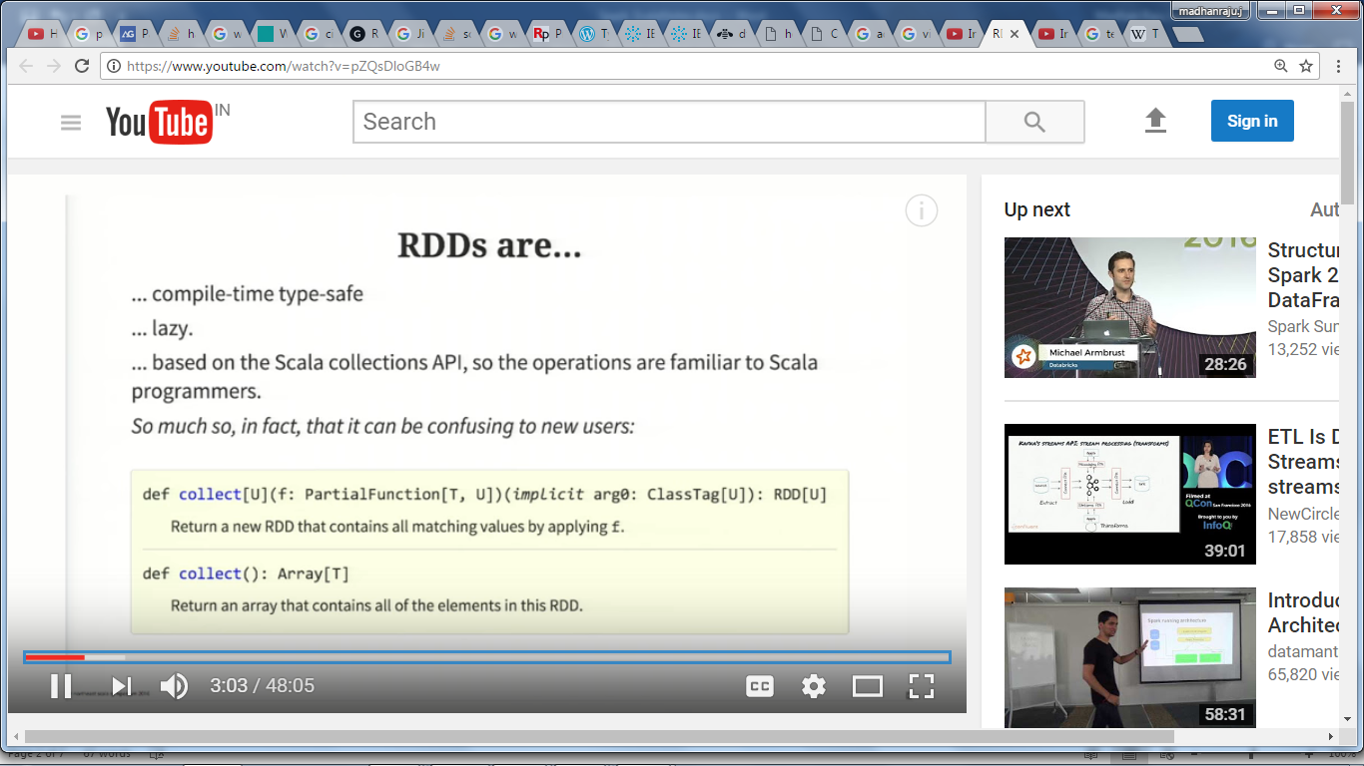

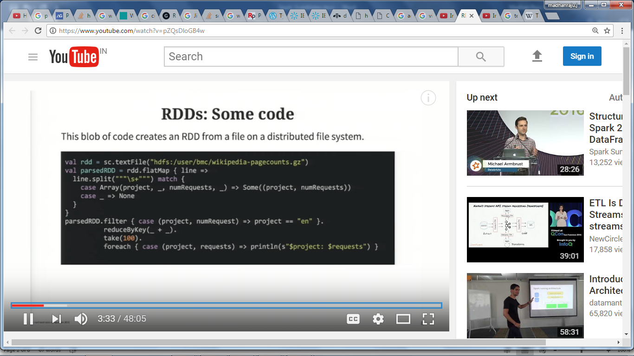

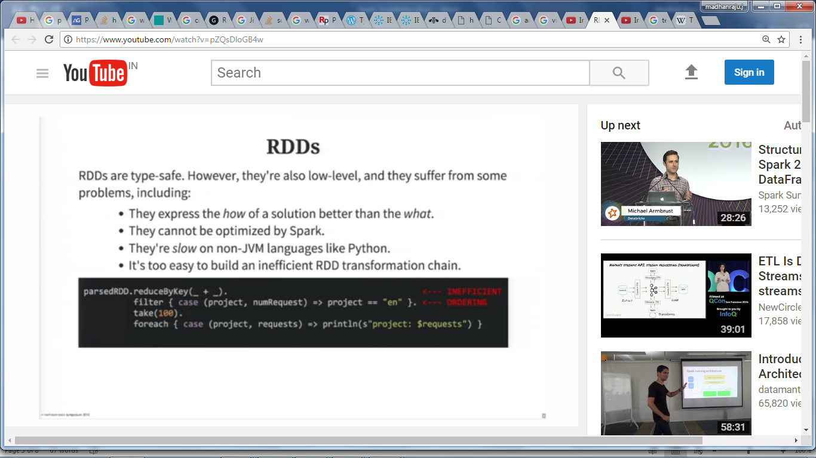

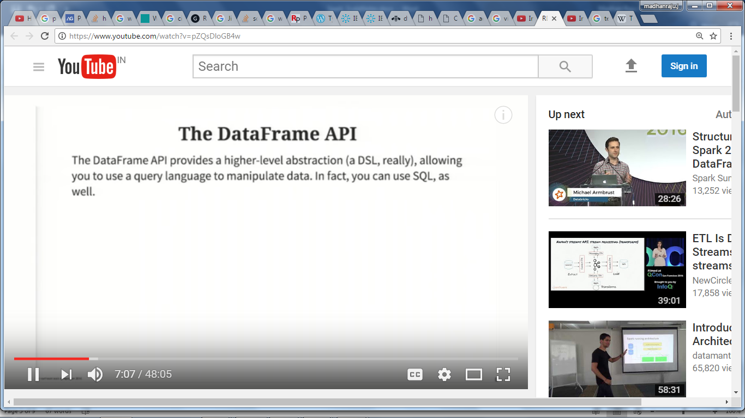

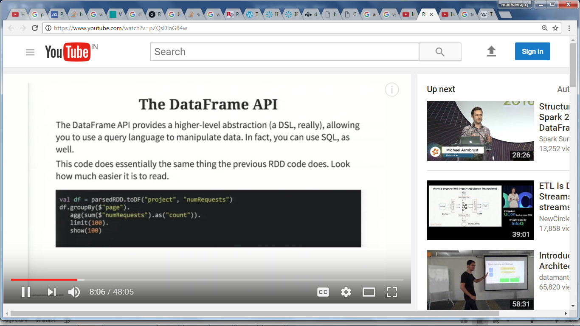

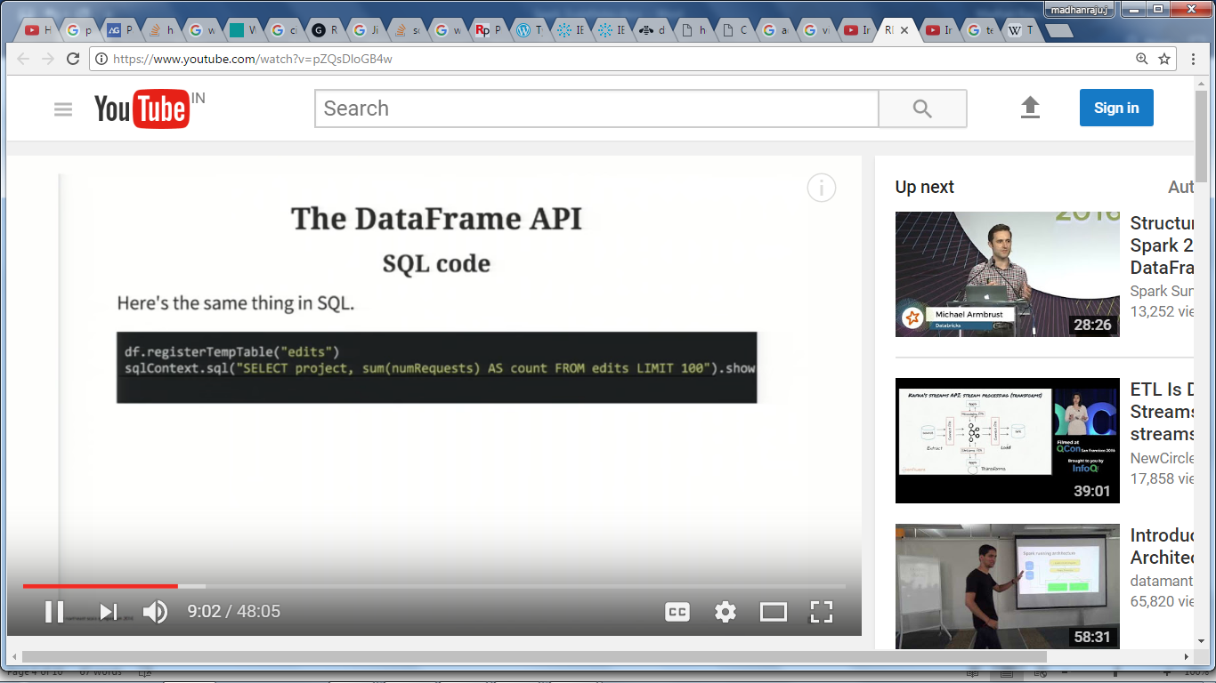

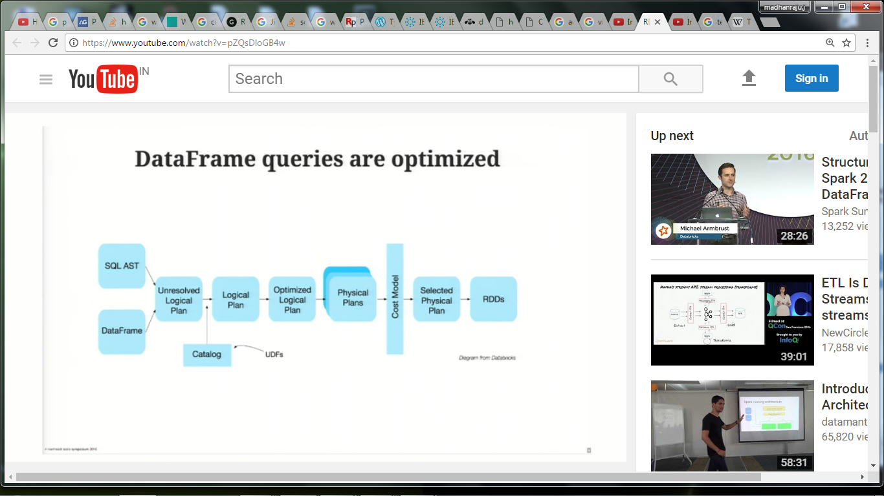

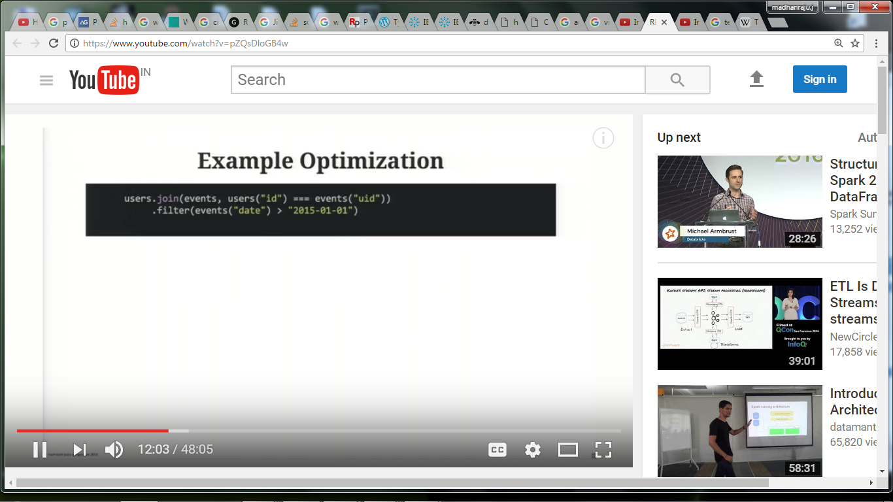

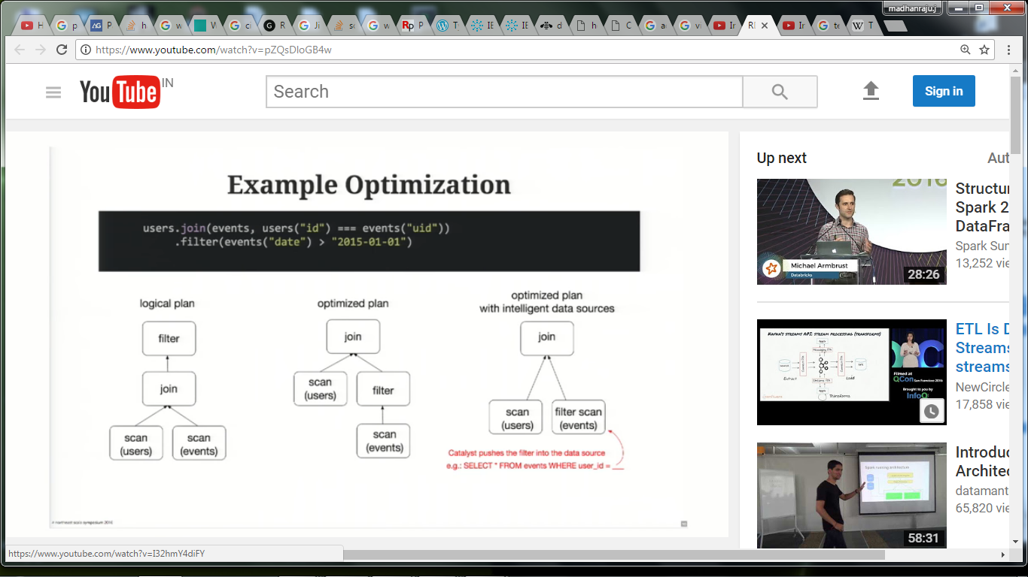

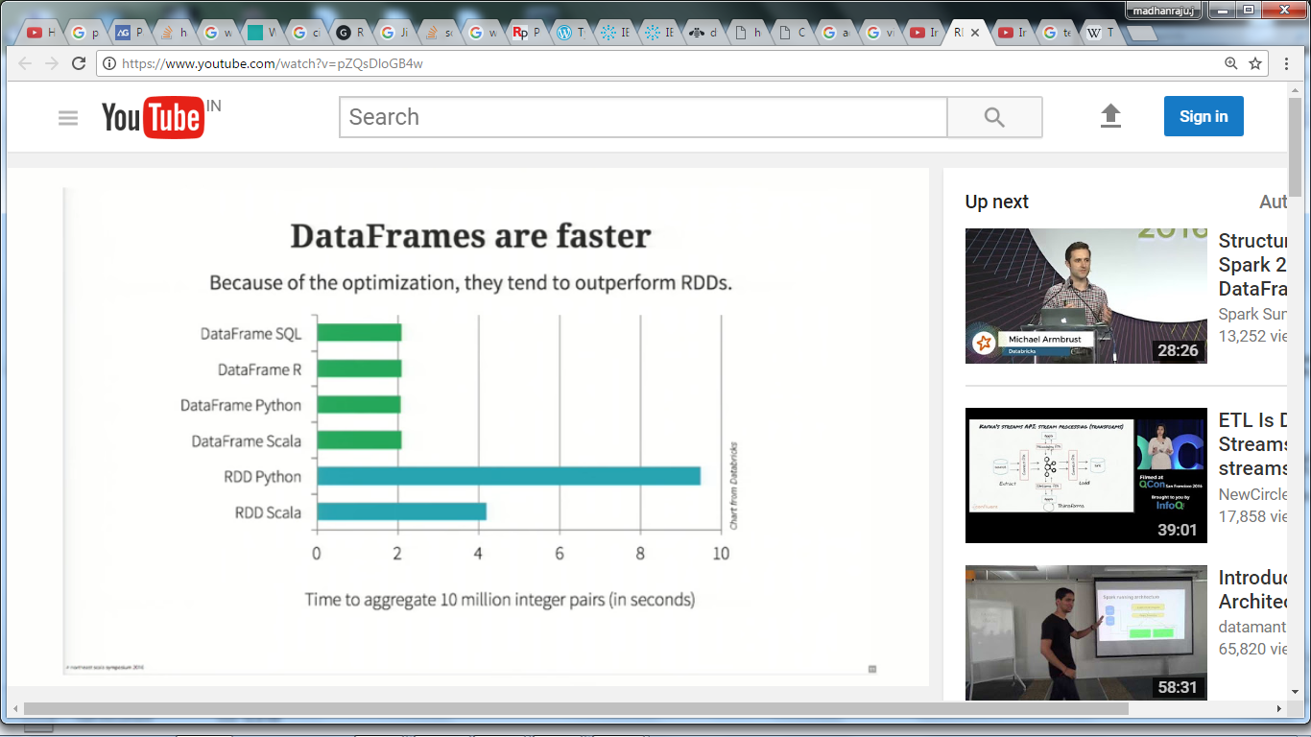

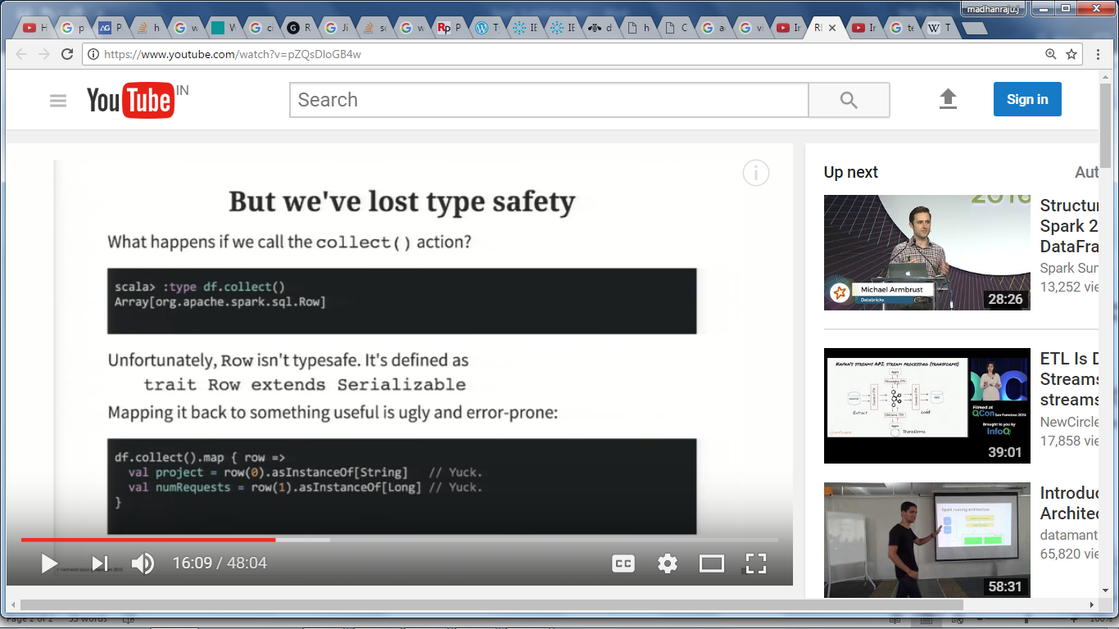

But we've lost type safety (to handle this they come up with DataSets)

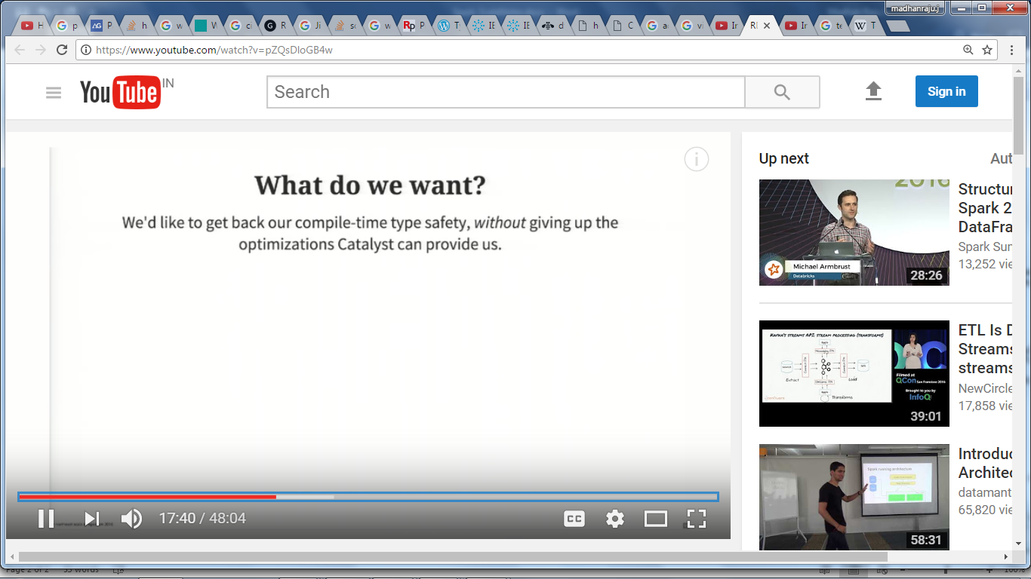

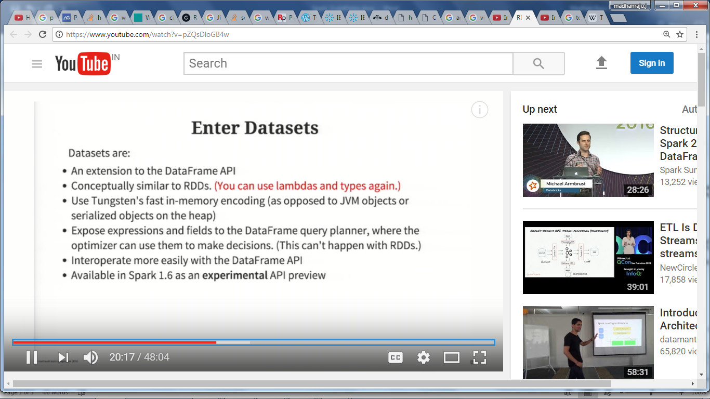

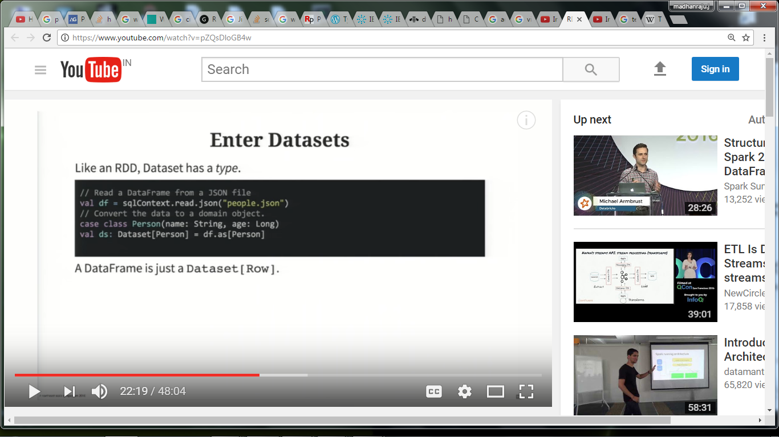

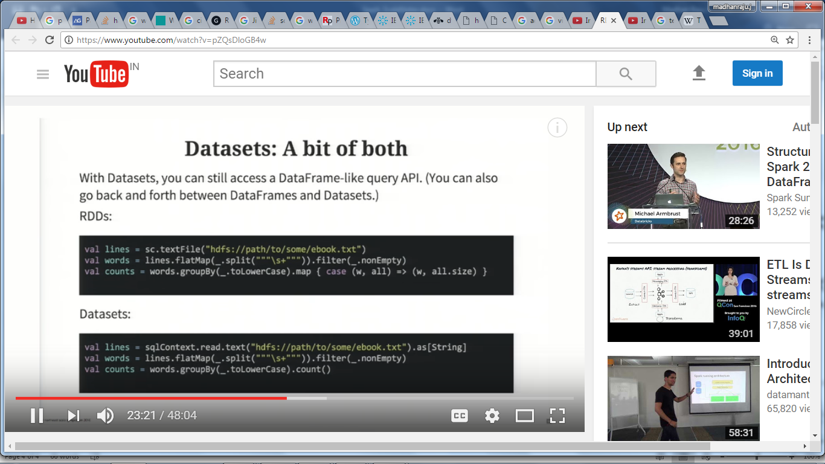\

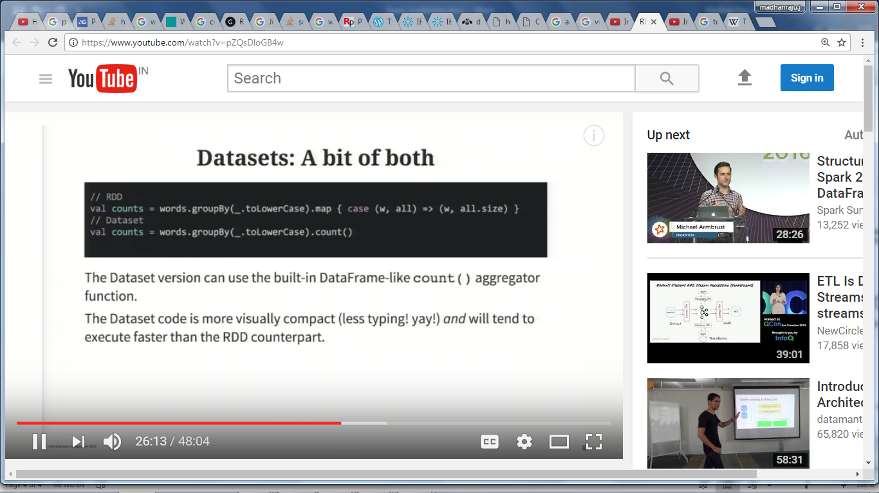

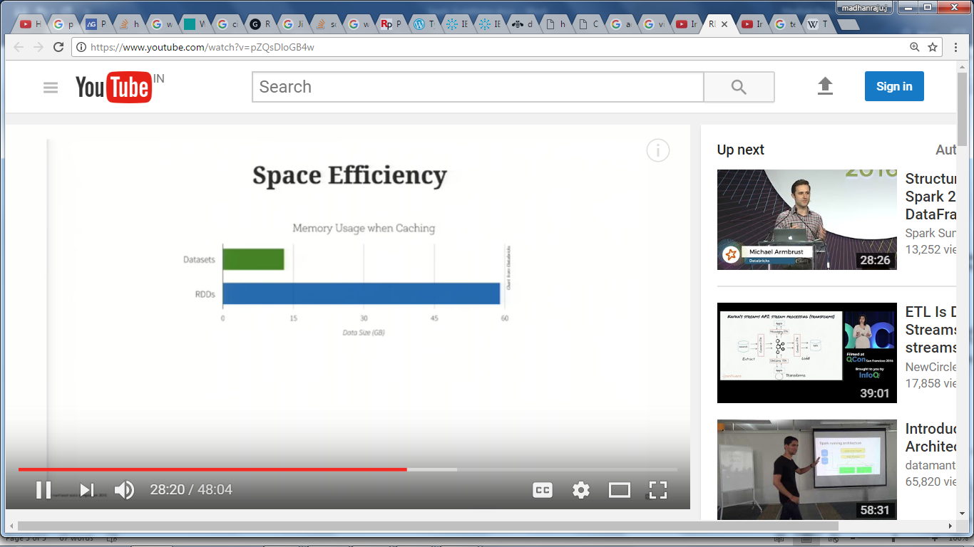

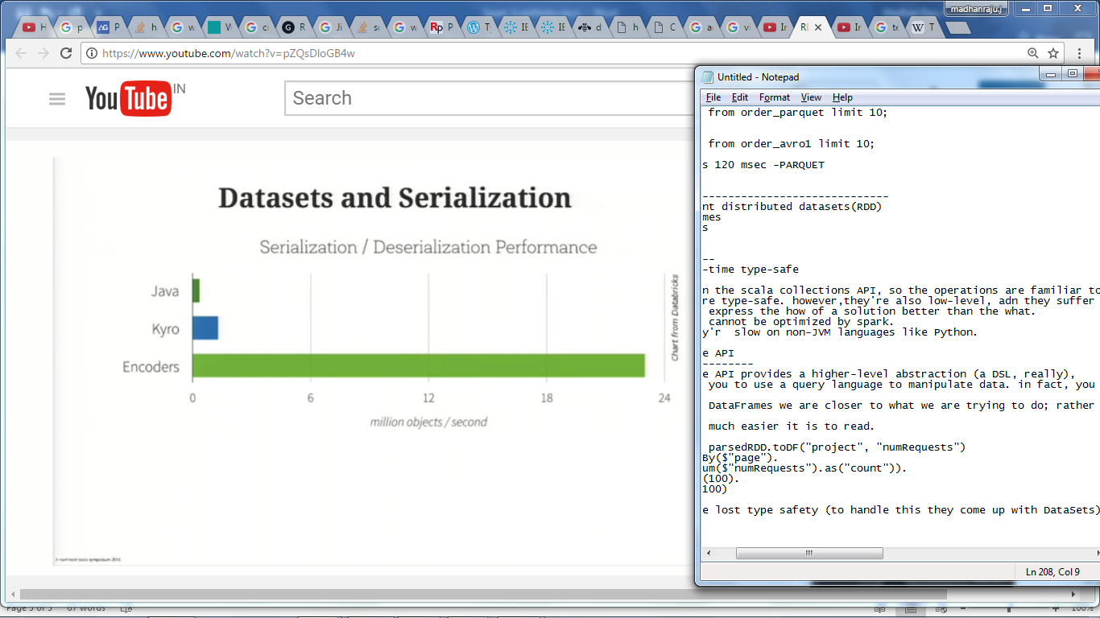

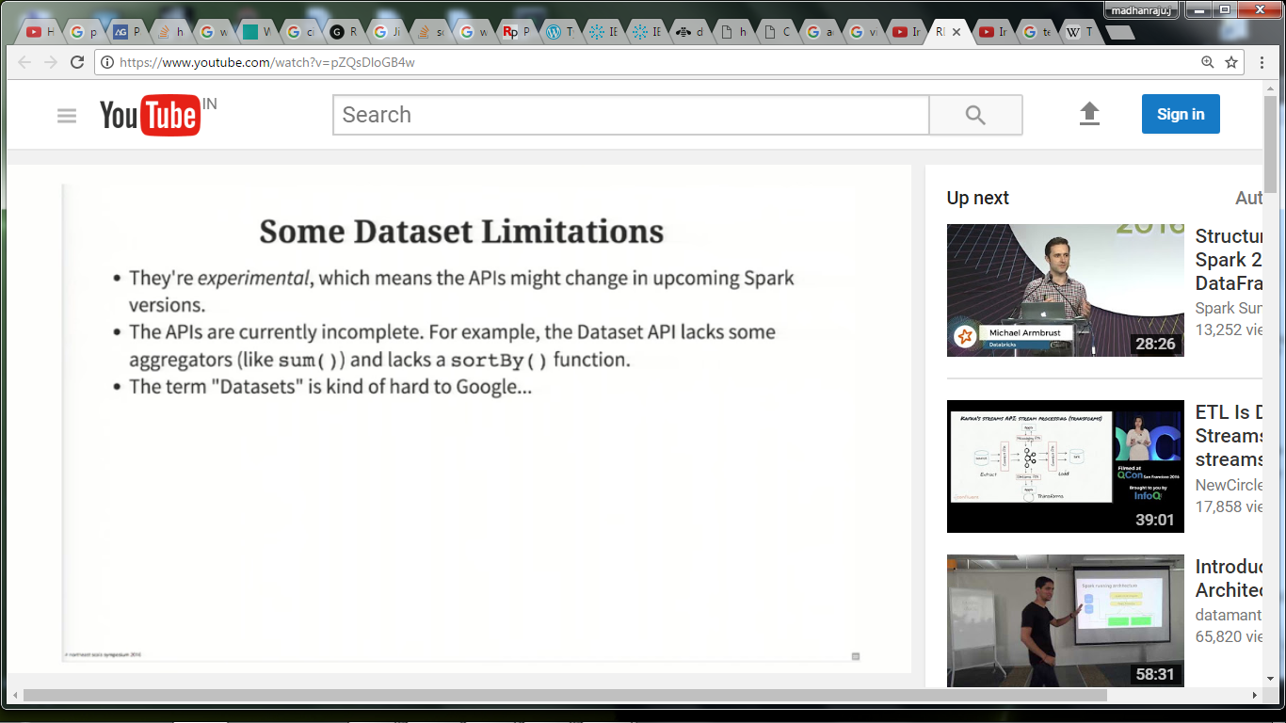

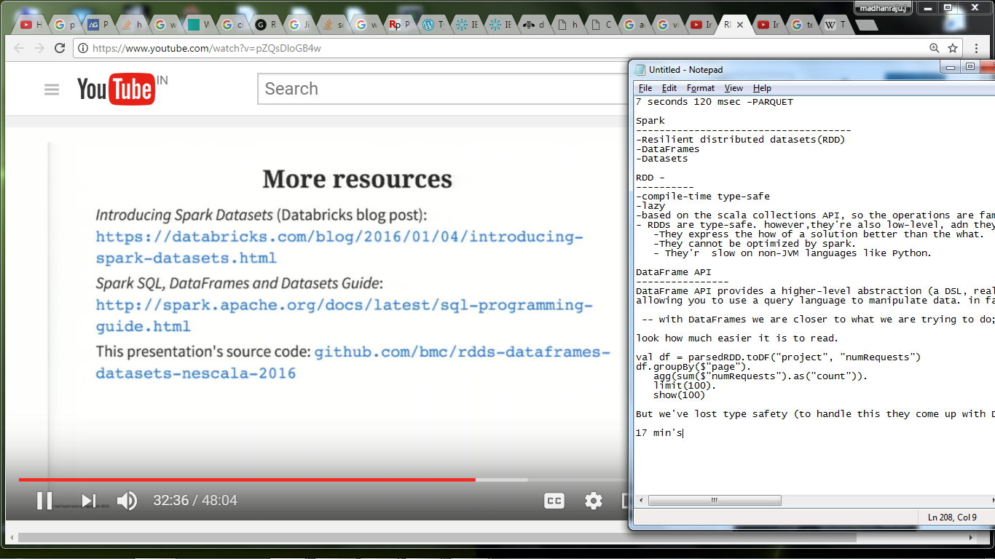

To read : Durga

Totally 19 videos

[Apache Spark using Scala](https://www.youtube.com/playlist?list=PLf0swTFhTI8p4bkrJuJdnZo5mDlDiHEVg)

https://www.youtube.com/watch?v=SWZ5V3oiD4o&list=PLf0swTFhTI8p4bkrJuJdnZo5mDlDiHEVg